Lab 3 - Viewing  
Computer Graphics CS4052  
Edmond O’ Flynn  
12304742

“Each viewport should show a different view of the teapot”

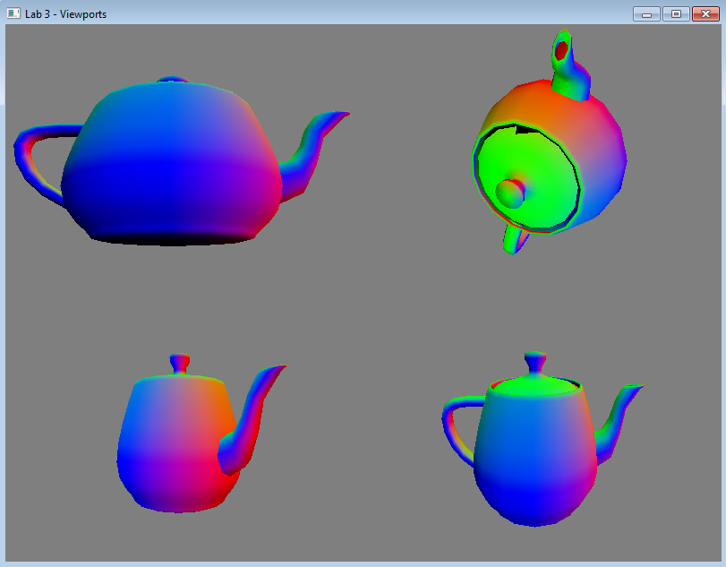

I modified the sample code given to have a class for viewports. In this class, I moved all repeatable code associated with displaying in order to reduce duplication of code, and allow for quicker modifications through refactoring.

“The teapot should appear moving in at least one viewport”

The top right and bottom left viewports move independently of one another through accessing independent viewport objects in the vector object.

U:\Assignments\CS4052 Lab 3 Edmond O Flynn 12304742\updated_draw.PNG

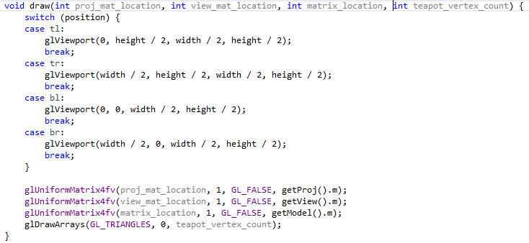

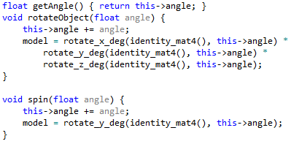

“The teapot should appear static in at least one viewport”

Two of the viewports have static objects that don’t undergo any transformations during update.

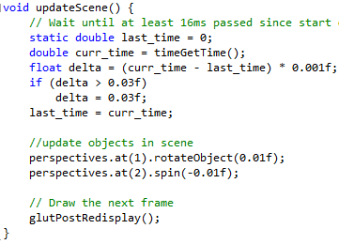

“At least one viewport should depict an orthographic projection, and you must do this using an orthographic projection matrix as presented in the notes”

Two constructors are provided, one for perspective viewports, and another for orthographic viewports. I used the given perspective function from the sample code, but I created my own mat4 viewport using some linear algebra.

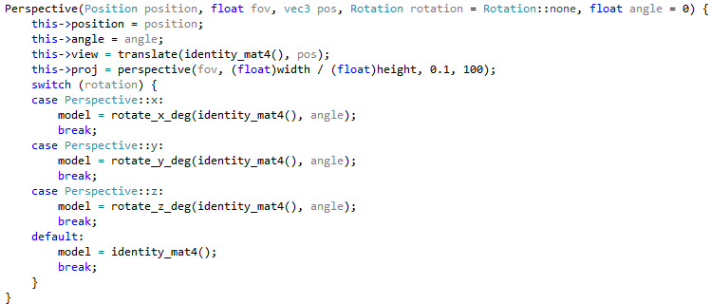

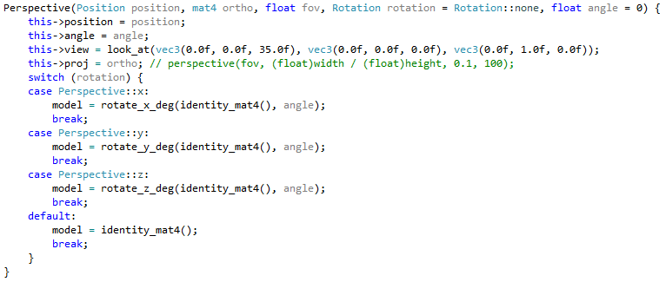

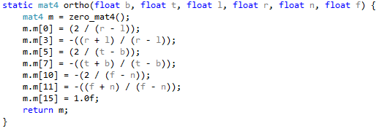

“At least two viewports should depict a perspective projection, each with different properties”

Both of the perspective viewports have different properties, one is static, the other is dynamic. The FOVs are different, as well as the positions of the objects in each respective viewport.

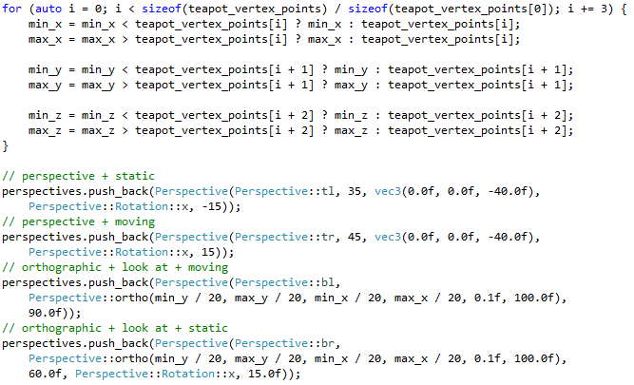

“At least one viewport should use the look-at function for the view matrix”

Both of the orthographic projections use the provided look\_at() function.

